INFORMATIONAL BRIEFING ON
SUBSURFACE TECHNOLOGY AND ENGINEERING CHALLENGES AND R&D OPPORTUNITIES:
CONTROL OF FRACTURE PROPAGATION AND FLUID FLOW

JULY 22, 2014

VENUE:
Executive Conference Room
United States Energy Association
1300 Pennsylvania Ave. NW
Suite 550
Washington, DC 20004

ORGANIZED BY:
United States Energy Association

SUPPORTED BY:
U.S. Department of Energy
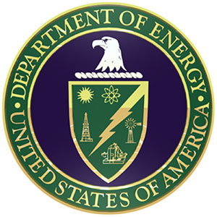

8:30 AM Introduction and Overview
Barry Worthington, Executive Director
United States Energy Association

8:40 AM U.S. Department of Energy (DOE) Subsurface Technology and Engineering (SubTER) Crosscut Technical Team – Status and Activities, Workshop Goals
Dr. S. Julio Friedmann, Deputy Assistant Secretary, Office of Clean Coal and Carbon Management; Mr. Doug Hollett, Director, Geothermal Technologies Office

9:10 AM Overview of National Laboratory Big Idea on Subsurface Technologies
Dr. Susan Hubbard, Senior Scientist and Division Director, Earth Sciences Division at Lawrence Berkeley National Laboratory

9:30 AM Key Challenges and Opportunities on Adaptive Control of Fractures and Fluid Flow in Subsurface Energy Extraction and Storage
Dr. Srikanta Mishra, Senior Research Leader, Energy & Environment, Battelle

10:00 AM Control of Fracture Propagation and Fluid Flow
Mr. Iraj Salehi, GTI Institute Fellow, Gas Technology Institute

10:30 AM Geophysical Monitoring of Subsurface Electrical Transient Signals for Fracture Detection and Characterization
Mr. John W. Pritchett, Geothermal Energy Association/ Leidos, Inc.

11:00 AM Wrap-up Discussion

11:30 AM Conclusion

