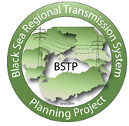
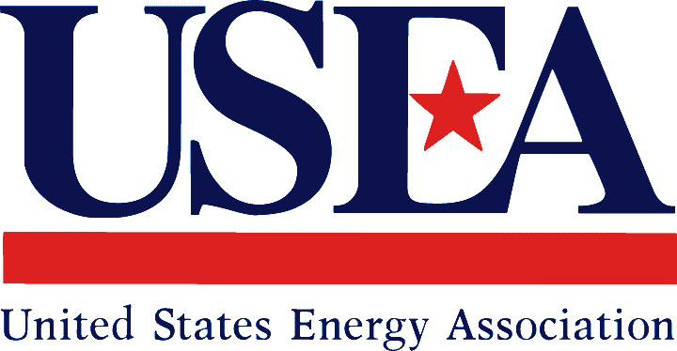

Energy Technology and Governance Program

BLACK SEA REGIONAL TRANSMISSION PLANNING PROJECT PSS/E HVDC MODELING WORKSHOP

SITE VISIT TO THE AKHALTSIKHE HVDC STATION

SUBAGREEMENT NO. USEA/USAID - 2017-708-01
March 21-23, 2017
Tbilisi, Georgia
Submitted by: Milos Stojkovic and Dragana Orlic, Electricity Coordinating Center (EKC)

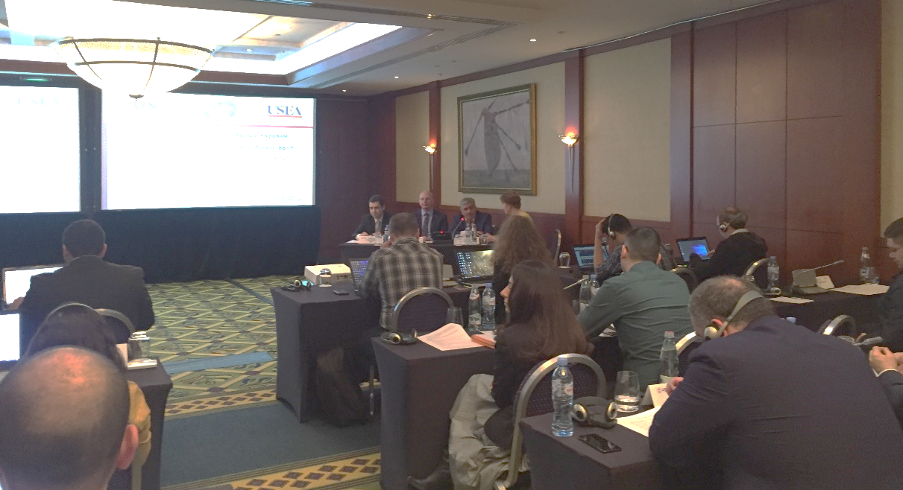
In cooperation with the United States Agency for International Development (USAID), the United States Energy Association (USEA) conducted a three-day Working Group PSS/E HVDC Modeling Workshop of the Black Sea Regional Transmission Planning (BSTP) Project in Tbilisi, Georgia from March 21 – 23, 2017. The workshop included also site visit to the Akhaltsikhe HVDC station which was organized in coordination with JSC “Georgian State Electrosystem” (GSE) and Energotrans Ltd. (daughter company of GSE which administers 500 kV OHLs “Vardzia” and “Zekari”, 500 kV OHL “Meskheti” and 500/400/220 kV SS Akhalstikhe.).
The main objective of the workshop was to build institutional capacities within national TSOs to use the HVDC equipment modeling facilities of the PSS/E software tool in order to support the HVDC model and analysis development.
The workshop was provided by Milos Stojkovic and Dragana Orlic, Electricity Coordination Center (EKC, Belgrade). The program was designed to improve the capacity of BSTP network planners to model and analyze HVDC converter stations within the regional context. This Workshop with corresponding process of regional model upgrading discussed the most important types of analysis that are necessary for the planning of HVDC based networks, addressing the simulation models which are recommended for each of these studies. The focus was on standard steady state and dynamic stability simulation analyses which are supported by regional BSTP PSS/E planning models for 2020 and 2025 (winter max, summer max and summer min regimes).
The interaction of HVDC converter with the connected power system is of complex nature and an accurate model of the converter is required to study these interactions. The use of analytical steady state and dynamic stability converter models provides useful insight and understanding of the interaction of the HVDC system and the connected system components. If accurate models are available, the system behavior can be studied in detail without introduction of too many simplifications. Modelling of HVDC based transmission systems require special attention as they contain non‐linear switching devices which are constantly operating, and hence creating transients all the time. For this purposes, special training model was developed in order to be appropriate and indicative represent of small and controllable transmission network.
Besides, taking into account whole complexity of these devices and rapid technological development, a special attention was paid to the theoretical aspects and implementation rules following ENTSO-E practice and appropriate Network Codes. Moreover, in order to anticipate next activities within BSTP which will track further improvement of regional simulation models and their usage in different kind of studies, this workshop could be considered as particularly valuable.
The workshop has been focused on the following topics:
- Theory and Methodology Aspects
  - LCC and VSC HVDC System
  - Control of HVDC Systems
  - Reactive Power Balance
  - Short Circuit Ratio
  - Additional Benefits of HVDC Systems
  - ENTSO-E HVDC Network Codes
- Practical Examples
  - PSS/E Load Flow and Short Circuit Basics
  - Steady State Modeling of LCC,VSC and Multi-Terminal HVDC
  - PSS/E Dynamics Basics
  - Dynamic Modeling of LCC,VSC and Multi-Terminal HVDC

A total of 30 engineers participated in the workshop representing the TSOs of Armenia, Bulgaria, Georgia, Moldova, Romania, Turkey and Ukraine:
Armenia
- Garnik Balyan , Chief Engineer, System Operator JSC
- Gurgen Harutyunyan, Energy Institute of Armenia
- Karine Khachbulaghyan, Senior Specialist, System Operator JSC
- Hamlet Zakaryan, Engineer, System Operator JSC
- Gurgen Aghababyan, Engineer, System Operator, JSC

Bulgaria
- Diana Stefanova, Transmission Network Planning Engineer, ESO EAD
- Rosen Ulinski, Transmission Network Planning Engineer, ESO EAD

Georgia
- Vasil Enukidze, Engineer, System Stability and Analysis Section, GSE
- Tamar Jikia, Senior Engineer, Electrical Regimes Statistic Section, GSE
- Inna Osikmashvili, Engineer, Transmission Grid and Development Section, GSE
- Givi Shovnadze, Engineer, System Stability and Analysis Section, GSE
- Giorgi Vakhtangadze, Head, Transmission Grid Planning and Development Section, GSE
- Davit Datashvili, Engineer, System Automatic Section, GSE
- Jemal Akhalaia – Deputy Director, Energotrans
- Akaki Nemsadze, Engineer, Energotrans
- Irakli Tkeshelashvili, Engineer, Energotrans

Moldova
- Octavian Ciobirca, Engineer, Electrical Regimes Department, Moldelectrica
- Varvara Gulco, Senior Engineer, Electrical Regimes Department, Moldelectrica
- Dmitri Zastavnethni, Engineer, Electrical Regimes Department, Moldelectrica

Romania
- Anca Antemir, Head of Network Development Office, Transelectrica
- Oana Zachia, Head of Forecast Consumption Office, Transelectrica
- Alexandra Tolea, Transelectrica

Turkey
- Necip Fazil Bakir, Assistant Manager, Transmission Planning and Coordination Division, TEIAS
- Zafer Mertoglu, Engineer, Transmission Planning and Coordination Division, TEIAS

Ukraine
Western Power System, Lviv
- Taras Nakonechnyy, Deputy Chief, Regime Service, Central Dispatch Service
NPC Ukrenergo, Kiev
- Mykyta Vyshnevskyi, Deputy Head Electric Modes Optimization Service, Dispatch Department, NPC Ukrenergo
- Alla Umanets , Senior Regime Calculation Specialist, Prospective Development Department
- Tetiana Tkachuk, Electrical Regimes Optimization Division
- Irina Stasyuk, Regime Calculation Specialist, Prospective Development Department
- Kostiantyn Lytvynenko, Regime Calculation Specialist, Prospective Development Department

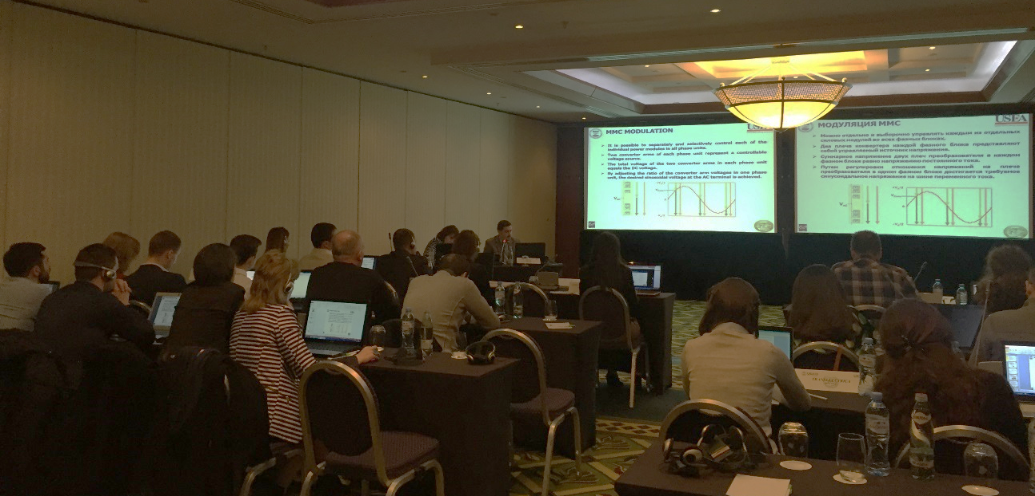

During the workshop, the Working Group members were accustomed with the different kind of steady state and dynamic stability calculation options which can be performed by the PSS/E software and there were presented different kinds of examples for practical usage of calculation results within standard and complex HVDC analysis studies.
Through hands-on exercises participants gained practical experience in HVDC analysis, modeling and preparation of reports; setting and managing input data; interpreting results; performing system calculation, including: standard load flow and short circuit analysis and dynamic and transient stability assessment, as well.

First day of the workshop, as it was mentioned, began with the site visit to the Akhaltsikhe HVDC station. It was whole day visit taking into account the distance from capital city and size and complexity of this station.
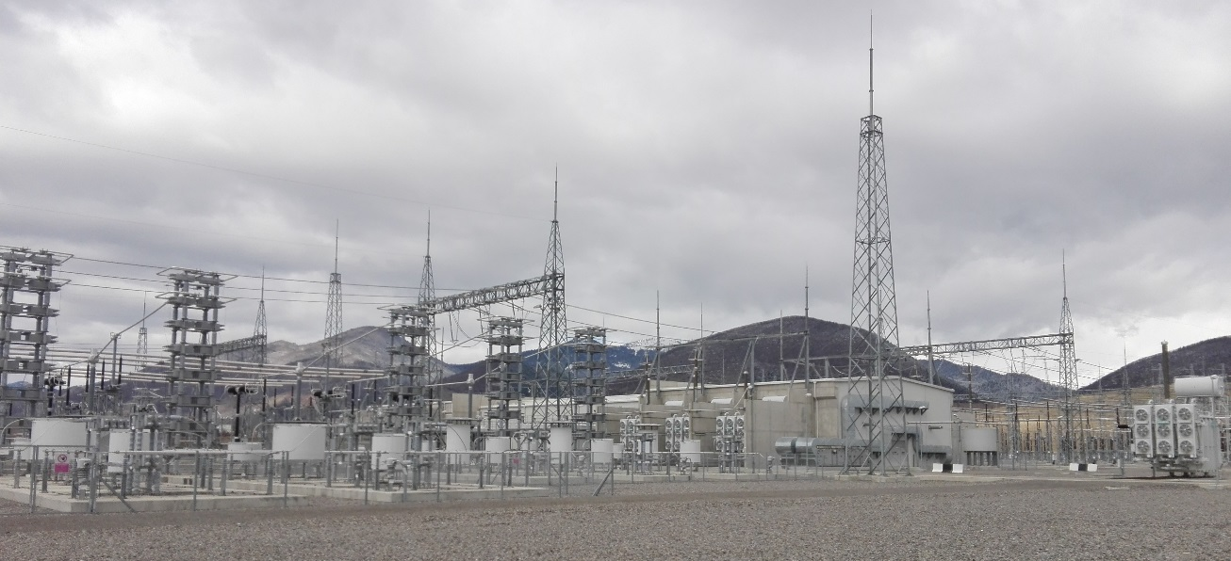
This was excellent opportunity for Working Group members to see the most important parts of such plant and to discuss with local engineers all theoretical and, in particular, all practical aspects of utilization of such devices. Special attention was paid to the operational issues and HVDC possibilities to control active power in both directions with very high flexibility.
Some of discussions were dedicated to the reactive power needs of such devices and applied solutions in this particular case taking into account chosen technology and its position within the power system of Georgia. There were several questions about these issues mainly from TSO representatives which are in the process of HVDC connections realization (DC links and asynchronous interconnections in Armenia, Georgia, Moldova and Romania).
Local engineers pointed to the fact that here was applied specific construction solution with hanging converters which considered seismically active ground.
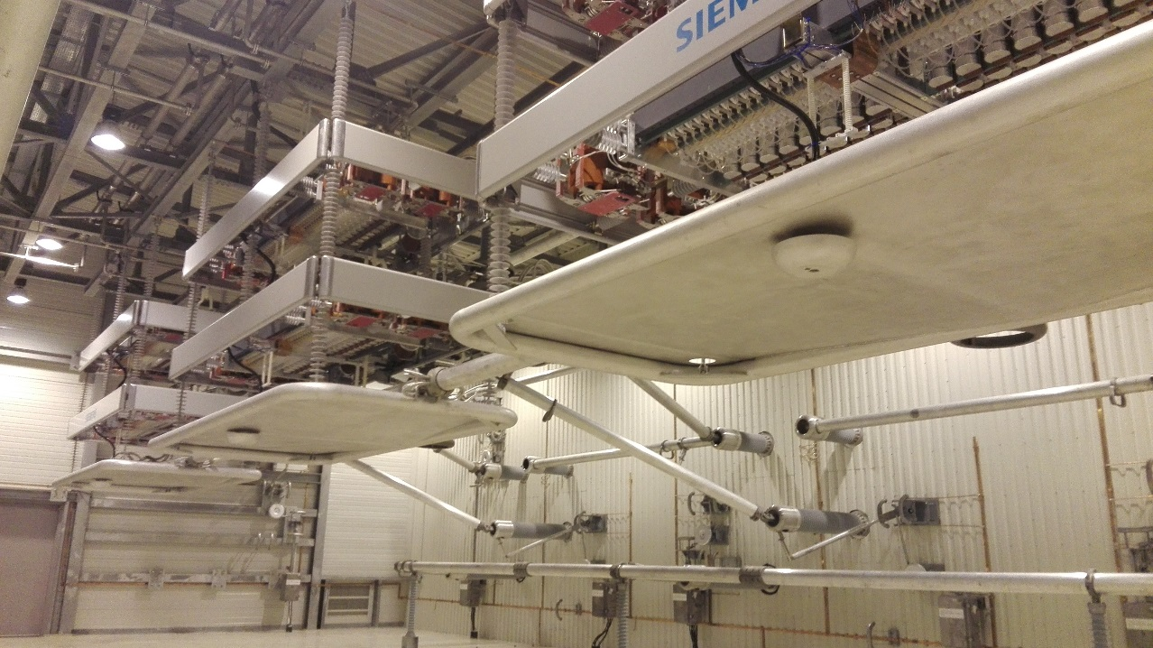
During the visit main focus was on control and services building which generally contains equipment rooms such as:
- Control room
- Cooling plant room
- Auxiliary supplies distribution
- Batteries
- Workshop
- Offices
In the end of the visit, Mr. Jemal Akhalaia, Energotrans Ltd. Deputy Director, gave us short presentation about some technical details and the history of this HVDC station.

Second day of the workshop began with general overview and main definitions in order to introduce participants with usual standard terminology and physical explanation of processes related to the different HVDC technologies. It was discussed history of HVDC development and their advantages in comparison with HVAC links. Afterwards, taking into account character of HVDC Systems (whether they are current or voltage links), there were discussing two main types of HVDC systems:
- Natural Commutated Converters with Capacitor Commutated Converters (CCC), known as CSC – Classic or LCC – Line Commutated Converters
- Forced Commutated Converters, known as VSC – Voltage Source Converters.
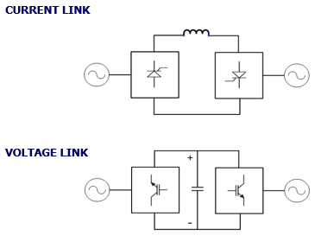
First, LCC HVDC Systems were explained from both, technical and theoretical point of view. This considered:
- Principal scheme;
- Explanation of converter station structure;
- Valve hall;
- AC filters (both, tuned or band-pass filters and damped or high-pass filters);
- Converter transformers;
- Earth electrodes;
- DC smoothing reactor; and
- DC filters
LCC HVDC Systems
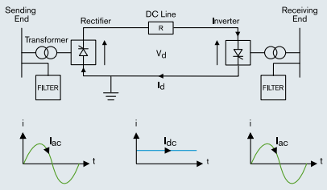
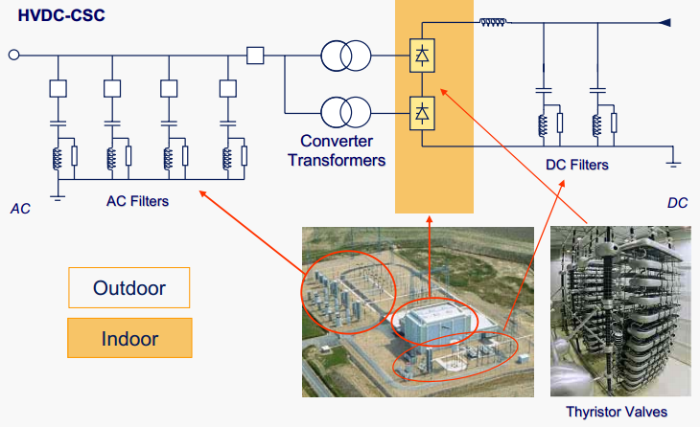
Further, different types of HVDC configuration schemes were discussed:
- Monopolar HVDC System with Ground Return
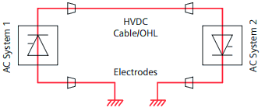
- Monopolar HVDC System with Metallic Return
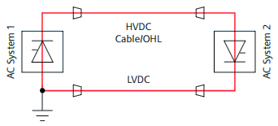
- Bipolar HVDC System with Ground Return
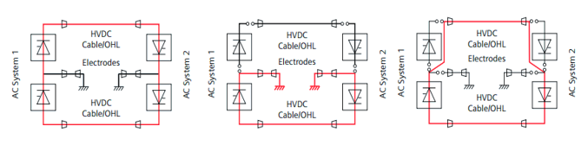
- Bipolar HVDC System with Dedicated Metallic Return
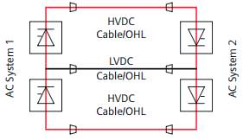
- Bipolar HVDC System without Dedicated Metallic Return
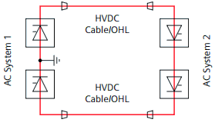
Then VSC HVDC systems were explained considering:
- Principal scheme;
- Explanation of converter station structure;
- Converter reactor;
- Pulse Width Modulation (PWM) Control;
- Modular Multilevel Converter (MMC) technology;

VSC HVDC Systems
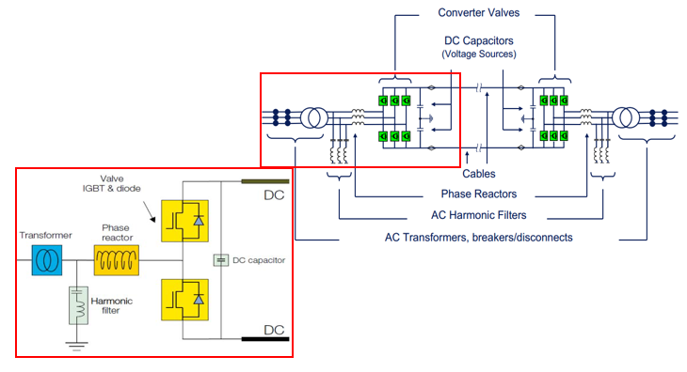
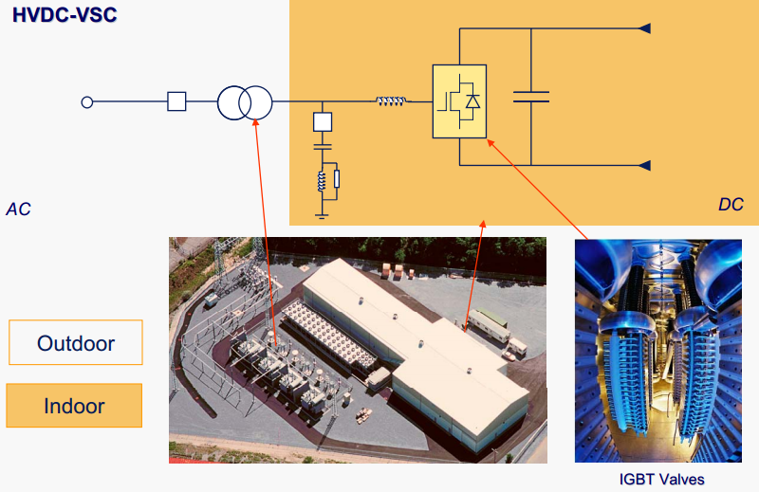
Further, Back-to-Back systems as a special case of monopolar HVDC interconnections and Multi-terminal HVDC Systems were discussed.
In the end, after the explanations of both technologies, their mutual comparison was performed taking into account different technical and operational aspects:
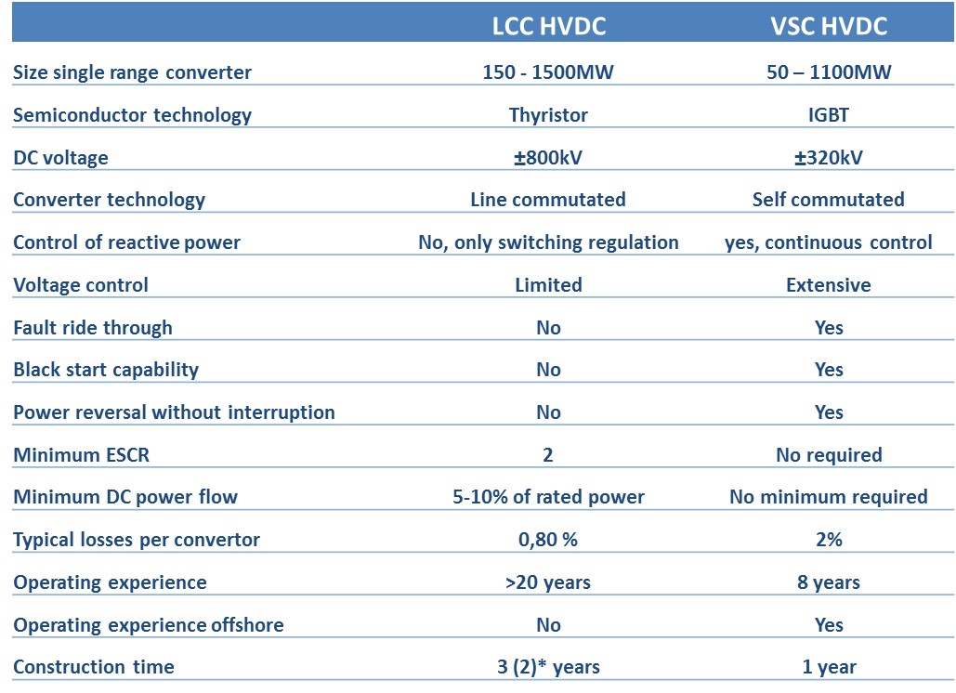
This part arised plenty of questions concerning the preferable technologies in different cases and mainly initiated by colleagues from Energotrans who are thinking about further extension of existing HVDC station and possibilities to use maybe other type of technology (currently is LCC). This was also interesting for Armenian and Moldavian TSOs which should build DC links in close future.
Next sessions were dedicated to the control of HVDC systems for both technologies (LCC and VSC) and reactive power balance, as well. Last one was also very interesting for participants taking into account specifics of their own power systems in terms of voltage-reactive circumstances. With this regards, next topic, Short Circuit Ratio (SCR) also provoke further discussion which was manly related to the appropriate assessment of possible and favorable places for DC links taking into account different technologies and calculated effective short circuit ratios. Some of these aspects have been elaborated during the previous Working Group Workshop on Short Circuit Analysis, but in any case, here the opportunity to repeat some rules and to link them with some specific HVDC devices was taken.
By the end of first day, after the recapitulation of additional benefits of HVDC systems, ENTSO-E Network Codes, related to this area, were presented. This covered different aspects, such as:
- Active power control;
- Automatic remedial actions including synthetic inertia and Frequency Sensitive Mode (FSM);
- Reactive power control;
- Fault Ride Through (FRT);
- Other requirements (Auto-reclosure, Converter energization and synchronization, Power oscillation damping capability, Sub-synchronous torsional interaction damping capability, Harmonics, Black Start capability, Isolated network operation, etc.)

Third day of the workshop began with an overview of the training model development procedure. Participants obtained already prepared input data for three types of HVDC links which can be used within PSS/E software:
- Two-terminal transmission models (including back-to-back HVDC systems)
- Multi-terminal transmission models
- HVDC employing VSC converters
Besides, they received all examples in PSS/E format together with all auxiliary files in order to easier follow each step during the practical examples’ part of the workshop which was mainly concentrated within third day.
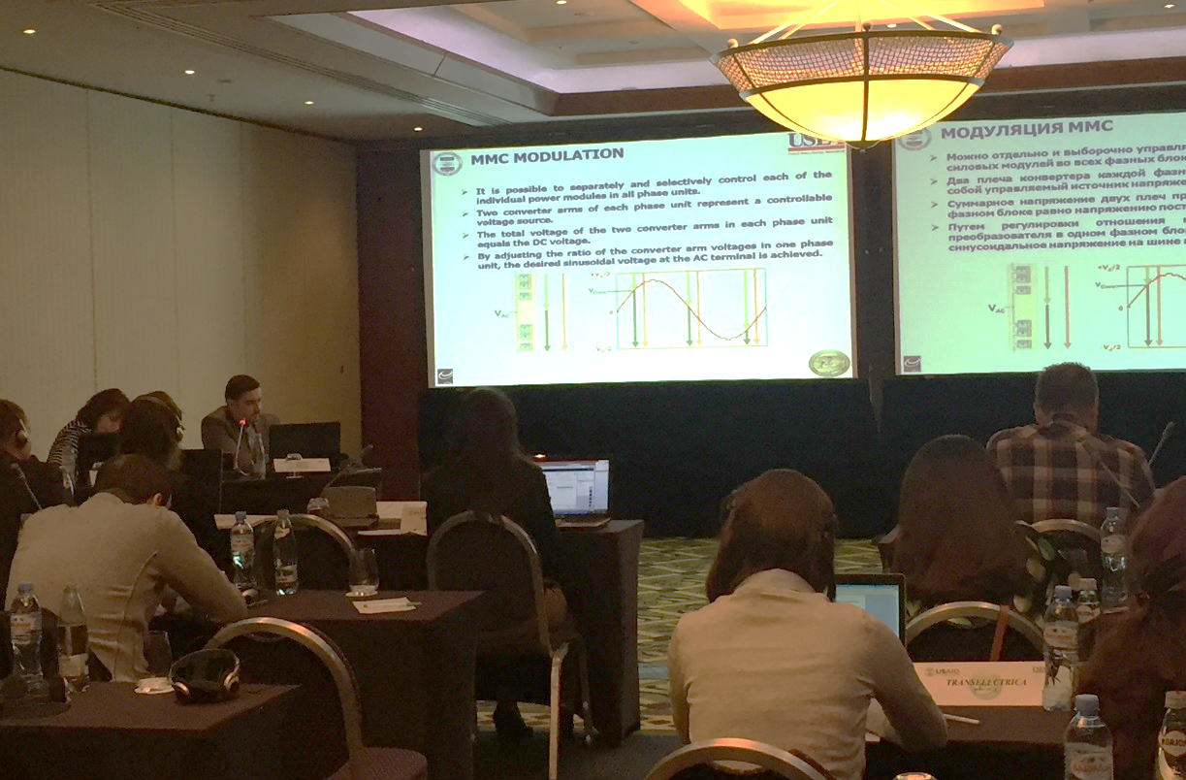
For the training purposes small and controllable transmission network model was used as starting grid for all changes and its structure was explained in detail. Main idea was to change standard HVAC link between two nodes by using different types of HVDCs (area in red ellipse).
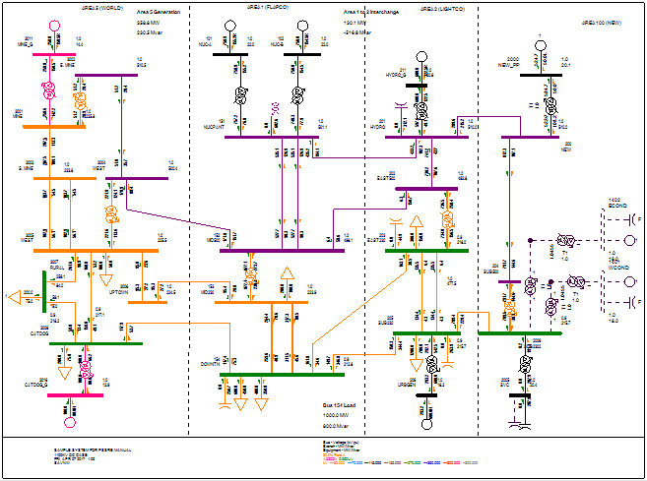
Afterwards, PSS/E software standard data base organization was explained together with basic calculation parameters’ settings, in particular concerning DC link automatic adjustments during the simulations. First group of three examples (for each HVDC model) was dedicated to steady state analysis.
Example 1 covered Steady State Modeling of LCC HVDC and Load Flow analysis. Initial step was to appropriately calculate necessary input parameters for the desired HVDC link together with all additional devices such as converter transformers, synchronous compensators and DC cables.
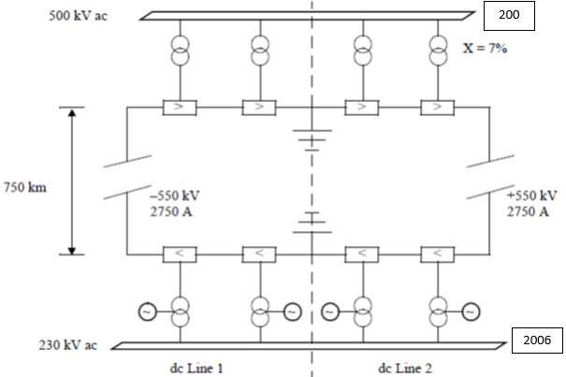
After the calculation of all necessary input data and their importing into the starting grid model within PSS/E, load flow calculation was performed and results were commented.
Example 2 introduced Steady State Model of VSC HVDC link. The same as in case of LCC, initial step was to appropriately calculate necessary input parameters with all additional devices. Then, all necessary input data were imported into the PSS/E, load flow calculation was performed and results were commented.
Example 3 dealt with Steady State Modeling of Multi-terminal HVDC and Load Flow analysis. There are possibilities for various configurations but here was presented the following:
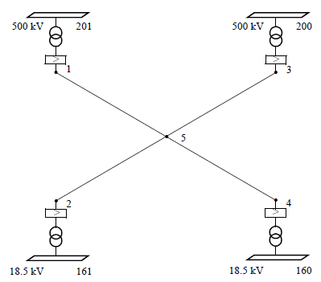
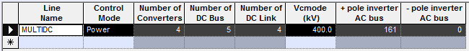
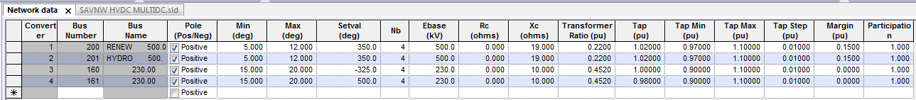
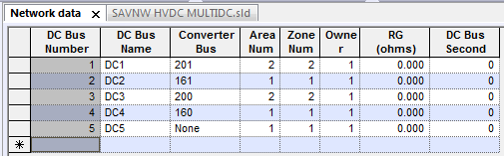
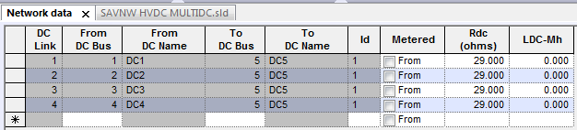

Next three exercises (for each HVDC model) were dedicated to dynamic stability analysis and dynamic stability models which focus was converter bridge control and its reaction on three phase faults at the AC connection points of HVDC devices. For all cases, fault duration was 100 ms and after the disturbance, calculated variables (given in red rectangles) have been damped as it was expected. There were used standard PSS/E internal data base models with the generic parameters.
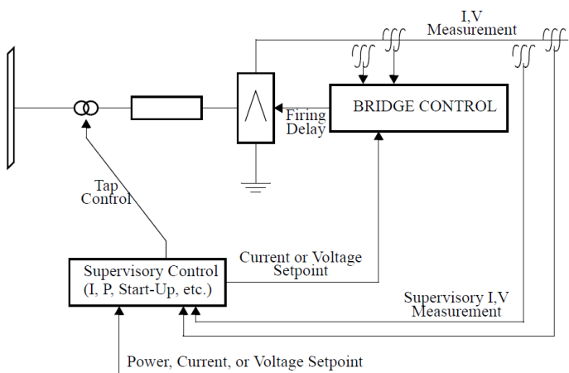
Example 4 was dealing with Dynamic Stability Modeling of LCC HVDC. Here was used basic generic model CDC4T. Its main parameters were explained including blocking voltage/time and bypassing voltage/time as well as appropriate voltage-dependent current limit characteristic.
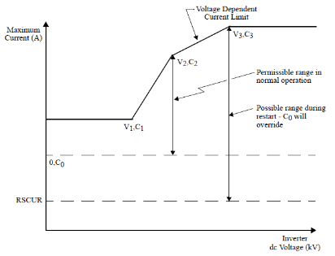
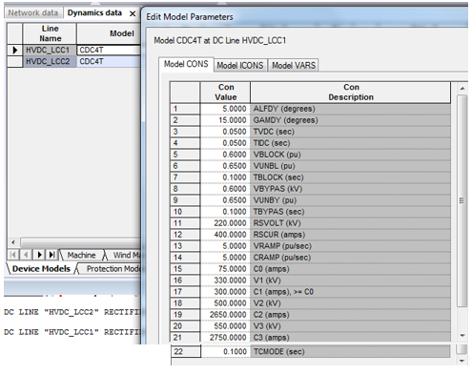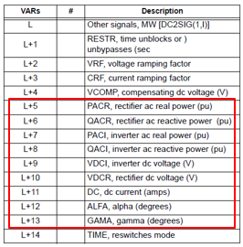
Example 5 was discussing Dynamic Stability Modeling of VSC HVDC and here was used VSCDCT generic model.
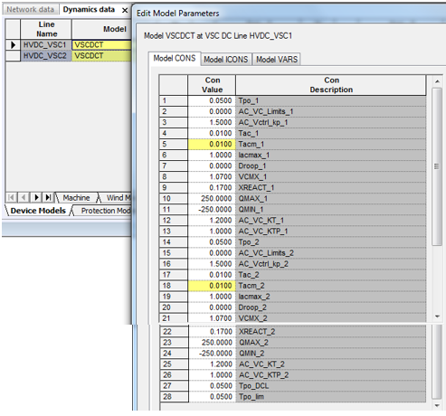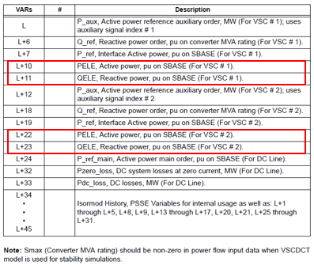
Example 6 was dedicated to the modeling aspects of Multi-terminal HVDCs and MTDC1T was used as generic model. It is based on CDC4T model and supports up to 5 DC terminals.
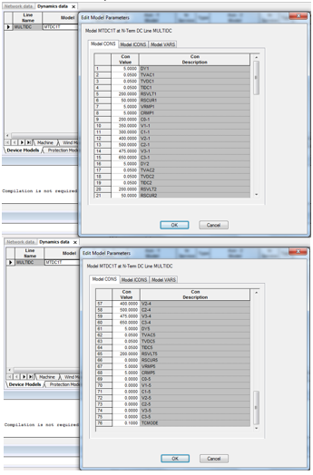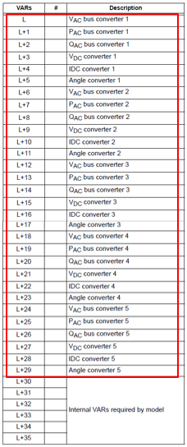

At the end, in order to recapitulate HVDC Modeling knowledge as well as to update regional models, some investigations were proposed to be issued by BSTP members. This includes preparation of small report presentation on existing and/or planned HVDC basic input data which should contain the following:
- Introduction
- Locations:
  - Existing Links
  - New Planned Links
- Status of the Existing Links
- Status of the Projects for New Planned Links
- HVDC Links Details:
  - Existing Links
  - New Planned Links
- Significance and Purpose
EKC will provide all necessary support from choosing of target power system elements, through the data checking until the finalization of necessary (short) reports in presentation from. Time frame would be from the beginning of April until the mid of May.

The workshop was held in good atmosphere among presenters and participants. Since the workshop was interactive, a lot of questions and requests for further explanations have been raised. Most of these questions were related to practical issues and experience from their national systems, in particular regarding short circuit calculation results concerning HVDC installation and power quality analysis.
All participants were satisfied with quality of the workshop and expressed ideas for further workshops, but no concrete ideas were discussed.
Participants were awarded Certificates of Achievement signed by USAID and USEA upon completion of the workshop.
