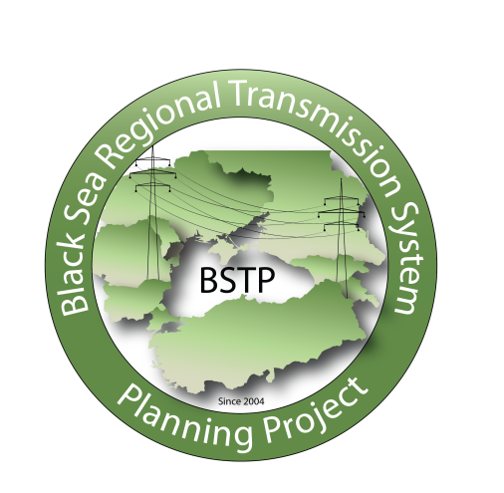

ENERGY TECHNOLOGY AND GOVERNANCE PROGRAM
BLACK SEA TRANSMISSION PLANNING PROJECT (BSTP)
VIRTUAL WORKING GROUP MEETING
May 27, 2020
7:00 AM – 8:30 AM (EDT)
1:00 PM – 2:30 PM CENTRAL EUROPEAN TIME
2:00 PM – 3:30 PM UKRAINIAN AND MOLDOVAN STANDARD TIME
3:00 PM – 4:30 PM ARMENIAN AND GEORGIAN STANDARD TIME

Please join our meeting from your computer, tablet or smartphone.
https://global.gotomeeting.com/join/487330773

Objectives
- Present the Impact of High RES on Possible Grid Constraints in the Black Sea Region Study Interim Report:

A primary objective of this study is to help Black Sea TSOs better prepare for future large-scale RES integration and anticipate the expected changes in network and market operations that will take place as cross-border transactions and markets open up regionwide. The study addresses both how electricity markets and prices will be affected by substantial amounts of RES development, and how the transmission grid will need to adapt – both within the BSTP countries and between them – as RES becomes a more significant share of the generation mix by 2030.

The market analysis includes hourly simulations of the power system with subsequent results for each hour of the year and will enable the BSTP to assess the impact of large-scale RES integration on wholesale market prices, country balances, cross-border flows and congestion costs; while the network analysis will enable BSTP members to better understand the effects of large-scale RES integration impact on load flows, voltage profiles, secure grid operations and congestion in the regional transmission network. Once the market and network models will be merged and testes, they will be transferred (in the Antares and PSS/E software platforms) to the BSTP Working Group members. The models will include all key data and explanations required for the BSTP members to use them for their own internal purposes and future analyses.

Meeting Agenda
OPENING AND WELCOMING REMARKS
- Garnik Balyan, Chairman of the Black Sea Regional Transmission System Planning Project, Electric Power System Operator of Armenia
- William L. Polen, Senior Director, United States Energy Association

IMPACT OF HIGH RES ON POSSIBLE GRID CONSTRAINTS IN THE BLACK SEA REGION STUDY
Presenters: Dragana Orlic, Branko Lekovic of the Electricity Coordinating Center of Belgrade
- Review and Discuss:
- Generation Capacities Technical and Economic Data
- NTCs Values
- National Network Models
- Review and Approved:
- Methodology
- Scenarios and Regimes

CONCLUDING REMARKS
- William L. Polen, United States Energy Association

