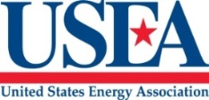
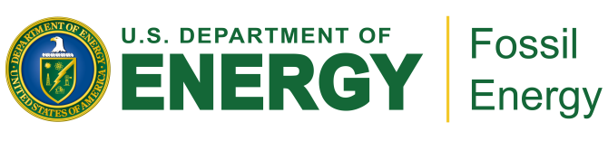

Workshop on the Future Paths of Emissions Reduction Technologies/Systems in the U.S.

June 13, 2019
Ronald Reagan Building and International Trade Center
1300 Pennsylvania Ave NW
Hemisphere Room A
Washington, DC 20004

8:00– 8:30 AM Registration Open

8:30–8:50 AM Welcome Remarks (Steve Winberg, Assistant Secretary of Energy, Office of Fossil Energy, U.S. Department of Energy)

8:50—9:15 AM Overview of Workshop Goals and Desired Outcomes (Angelos Kokkinos, Associate Deputy Assistant Secretary, Office of Clean Coal and Carbon Management, U.S. Department of Energy)

9:15-9:45 AM How can System Analysis Techniques be Applied to Process Innovation: (David Miller, National Energy Technology Laboratory)

9:45–10:15 AM Overview of Emission Reduction Strategies, a Fossil Energy Perspective: (Thomas Feeley, National Energy Technology Laboratory)
10:15 – 10:30 AM Break

10:30 –12:00 PM Breakout Groups: Group break out group discussions. (1) What challenges and additional R&D are needed to identify promising, early-stage reduction technologies or improvements to current BACT technologies? (2) What potential value-added products can be produced from coal combustion residues that can offset or reduce potential increased costs associated with introduction of new reduction technology. What R&D do we need to focus on reducing the legacy liability of ash ponds and ash storage? (3) What advances in emission reduction, isolation or solid waste containment technologies/ management strategies do you envision can come online within the next 5 to 10 years?

12:00 PM Working Lunch

12:00—2:00 PM Breakout Groups (continued)

2:00 – 4:00 PM Reports from Breakout Groups

4:00 – 4:30 PM Closing Remarks

